**Table of Contents**



**FPT International School**

--- o0o ---

**PROJECT REPORT**

**Bright LED**

Batch: C1706L

Semester: 1

Group: 4

1. Student1029299 Nguyen Quoc Anh
2. Student1045002 Nguyen Thu Thao
3. Student1045006 Nguyen Ngoc Thuy

**Hanoi - 11/2017**

1. Problem Definition 3

1.1 Overview 3

i. Introduction 3

ii. Implementation Environment 3

1.2 User Stories 4

Customer 4

i. Log in 4

ii. Register 4

iii. Search by name 4

iv. View the description of each product 4

2. Follow chart 5

2.1 GUI 1: login 5

2.2 GUI 2: Register 6

2.3 GUI 3: search by names 7

2.4 GUI 4: View descripton of each product 8

3. UI\UX 9

3.1 Homepage 9

3.2 Categories 10

3.3 Product details 11

3.4 About us 12

3.5 Contact us 13

3.6 Feedback 14

3.7 Cart 15

3.8 Login 16

3.9 Register 17

3.10 All Brands 18

3.11 Brands Details 19

3.12 All Categories 20

4. Summary 21

# Problem Definition

## Overview

### Introduction

**Requirement Specification:**

The Web site is to be created based on the following requirements.

1. The Home Page should be created making use of Sections with a suitable logo, the header section can be added which will show images of various LED Lights.
2. The site must contain the links to navigate through various types of LED Lights.
3. Links of LED Lights can be categorized like (Bulbs, Spot Lights, Decoration Lights, Smart Lights etc.)
4. Specification and Pricing of Lights should be added along with the images.
5. Website should provide section for various brands offered in the store.
6. Gallery section should be added for viewing different images.
7. Feedback must be allowed to enter by the viewer
8. Site map, Gallery, about us, Queries link, Contact us link must be added. Address of the Company should be displayed using GeoLocation API (eg. GoogleMaps) and the email address which when clicked will invoke the local mail client from where they can send an email.
9. The complete description must be allowed to get download as pdf or doc file.
10. The advertise section with various facilities provided should be mentioned.

### Implementation Environment

* Platform
* Windows 10
* Language
* HTML 5
* CSS3
* Javascript
* JQuery
* Bootstrap 3
* Application
* Dreamweaver CS6
* Chrome
* FireFox
* Methodology: Scrum

## User Stories

## Customer

### Log in

As a customer , i want login to the website

### Register

As a customer , i want register to the website

### Search by name

As a customer , i want search the products by their name

### View the description of each product

As a customer , i want contact to admin

# Follow chart

## GUI 1: login

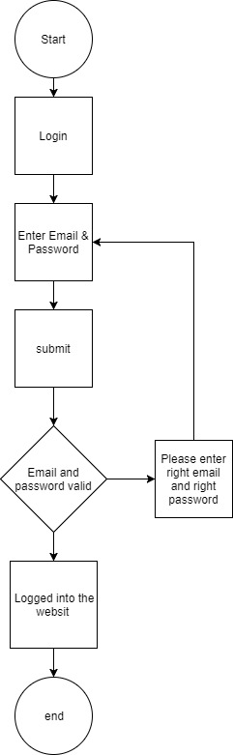

## GUI 2: Register

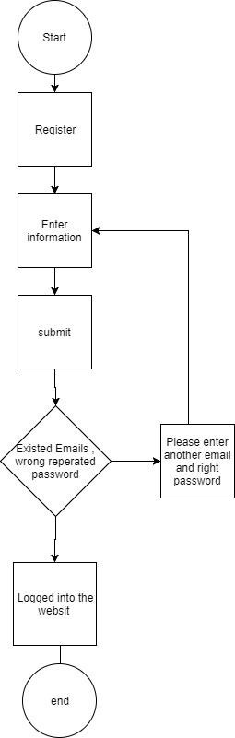

## GUI 3: search by names

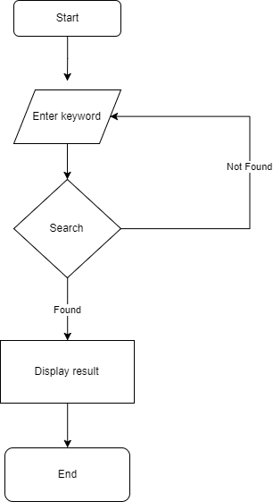

## GUI 4: View descripton of each product

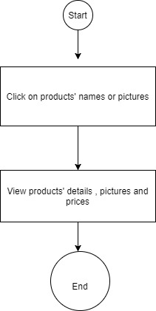

# UI\UX

## Homepage

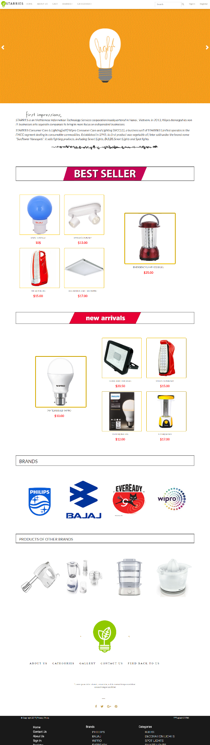

## Categories

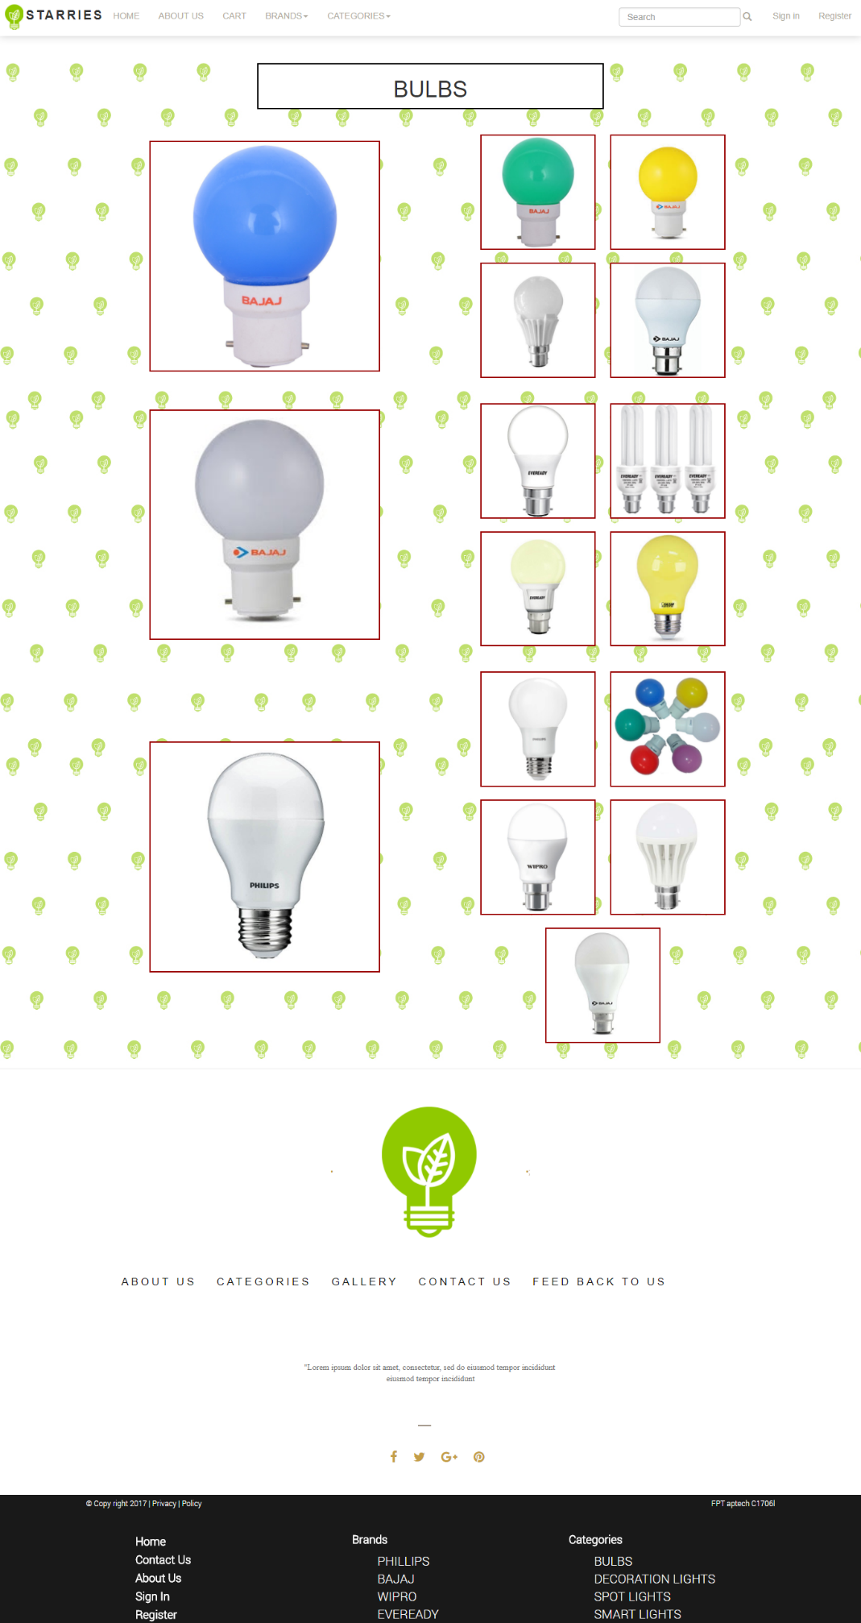

## Product details

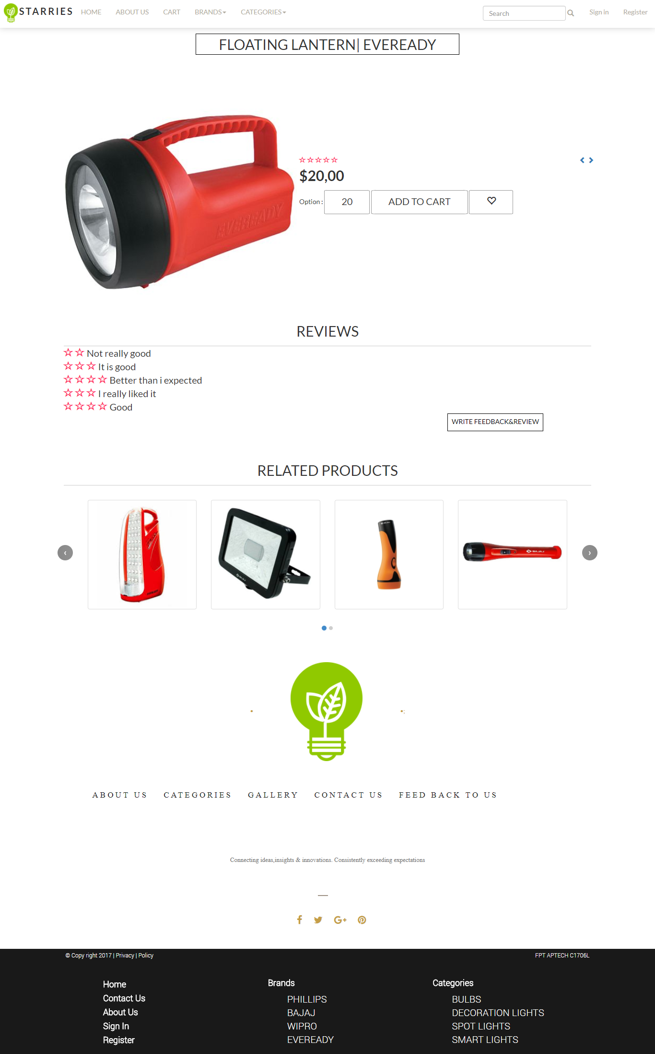

## About us

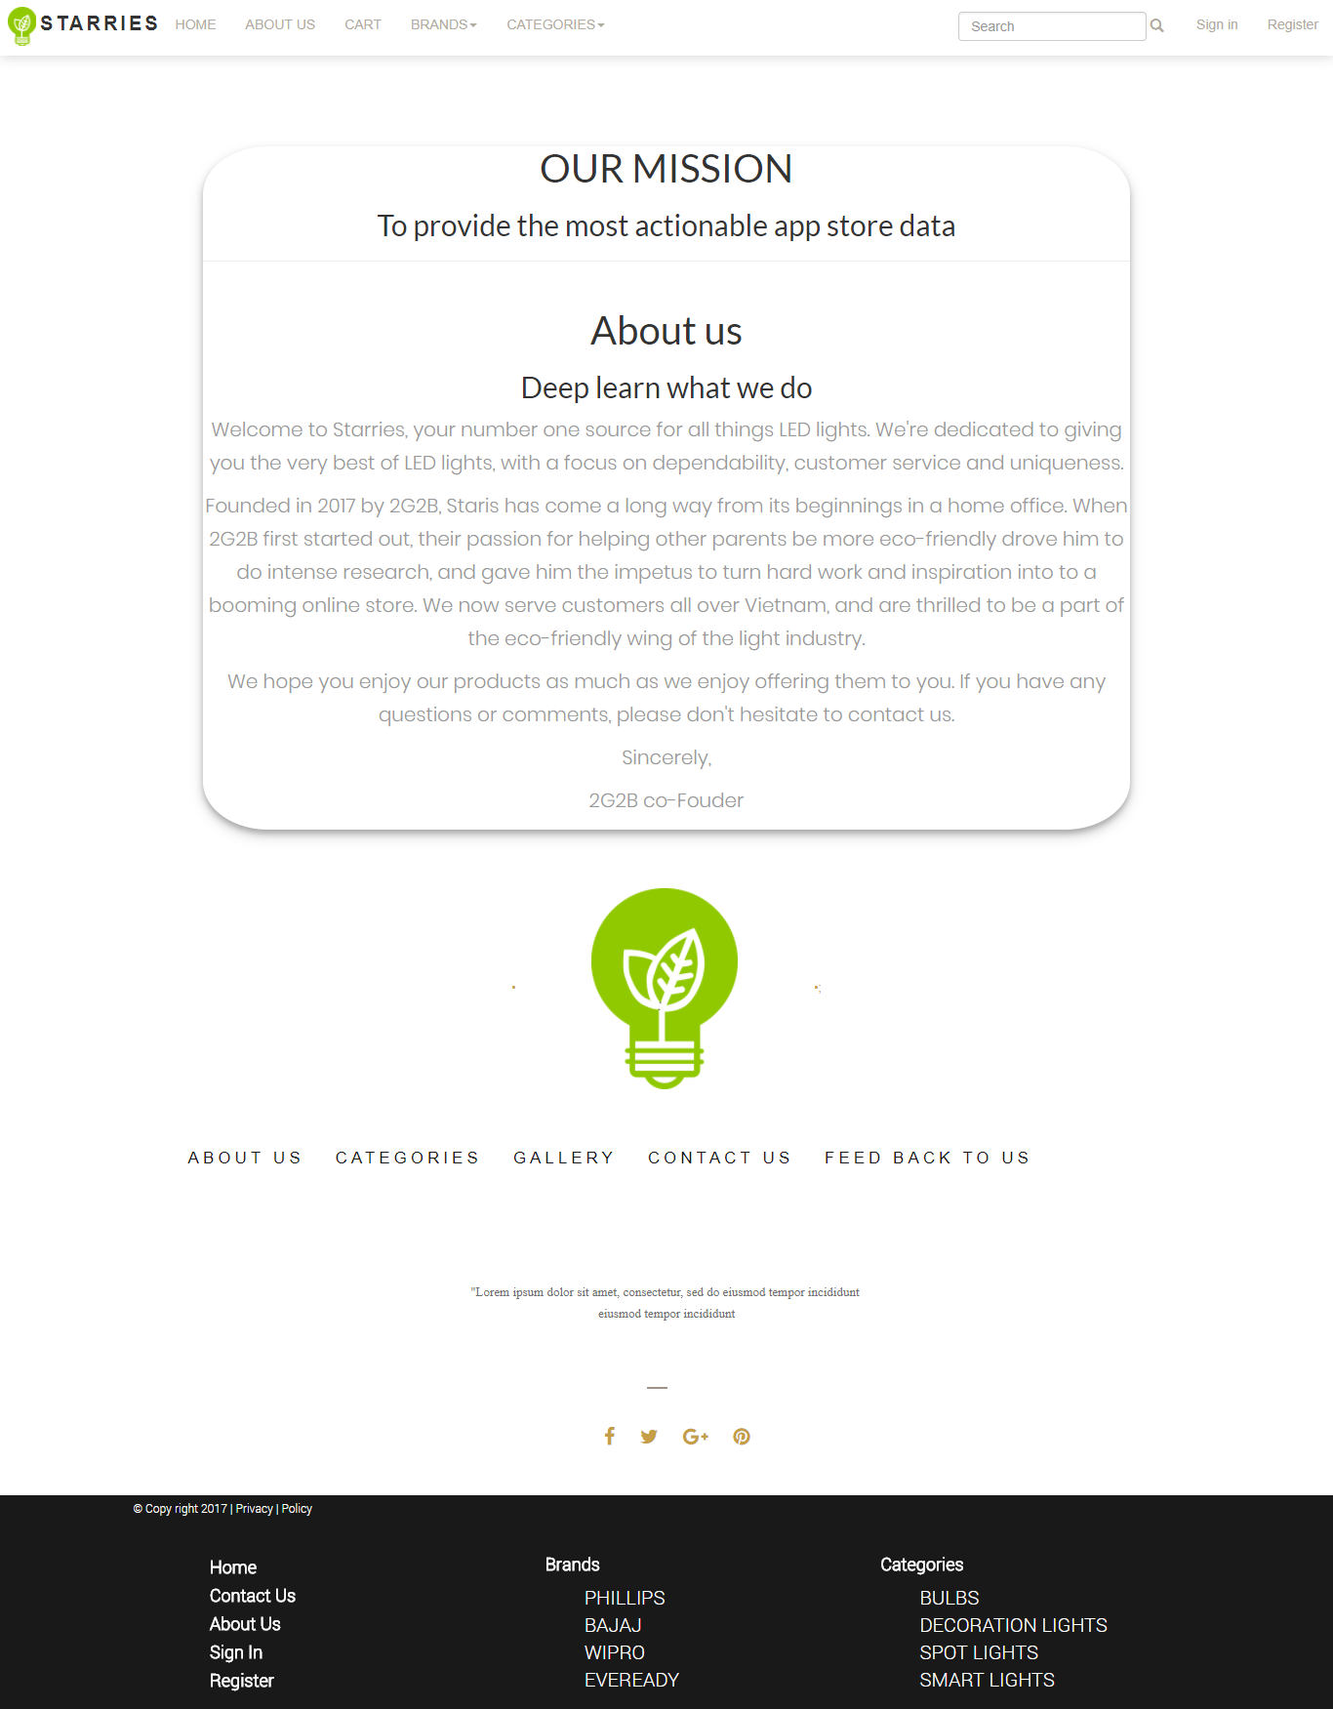

## Contact us

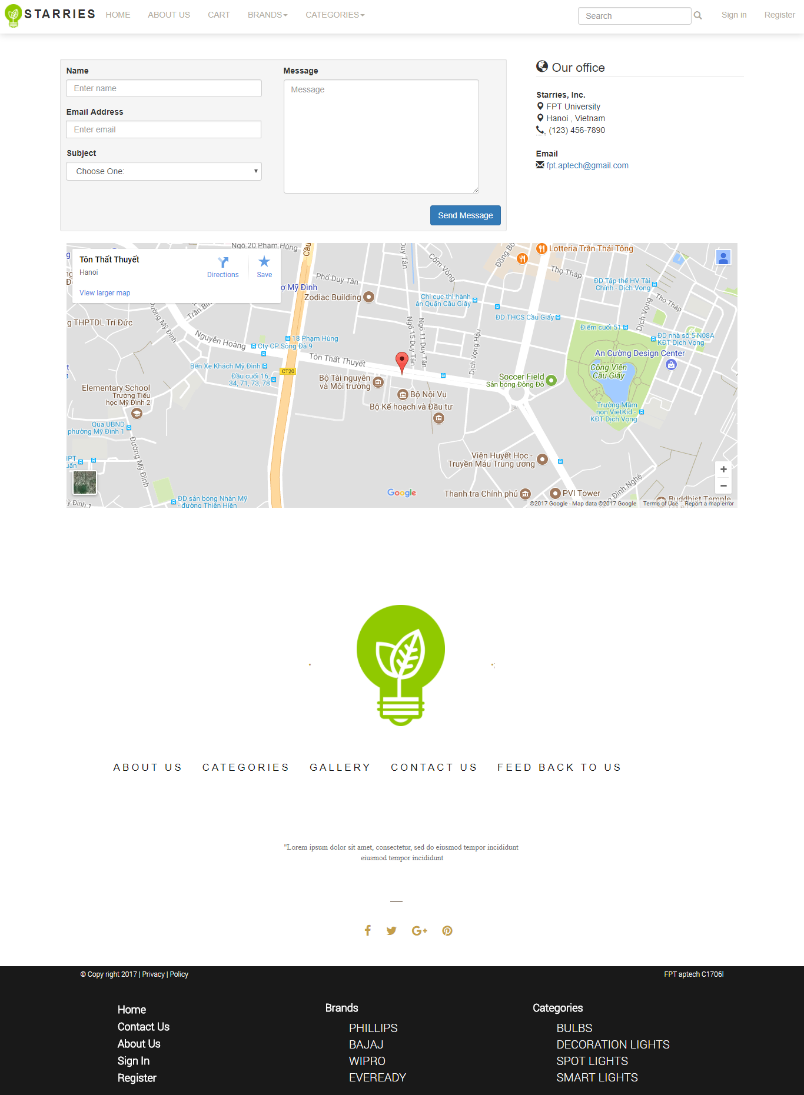

## Feedback

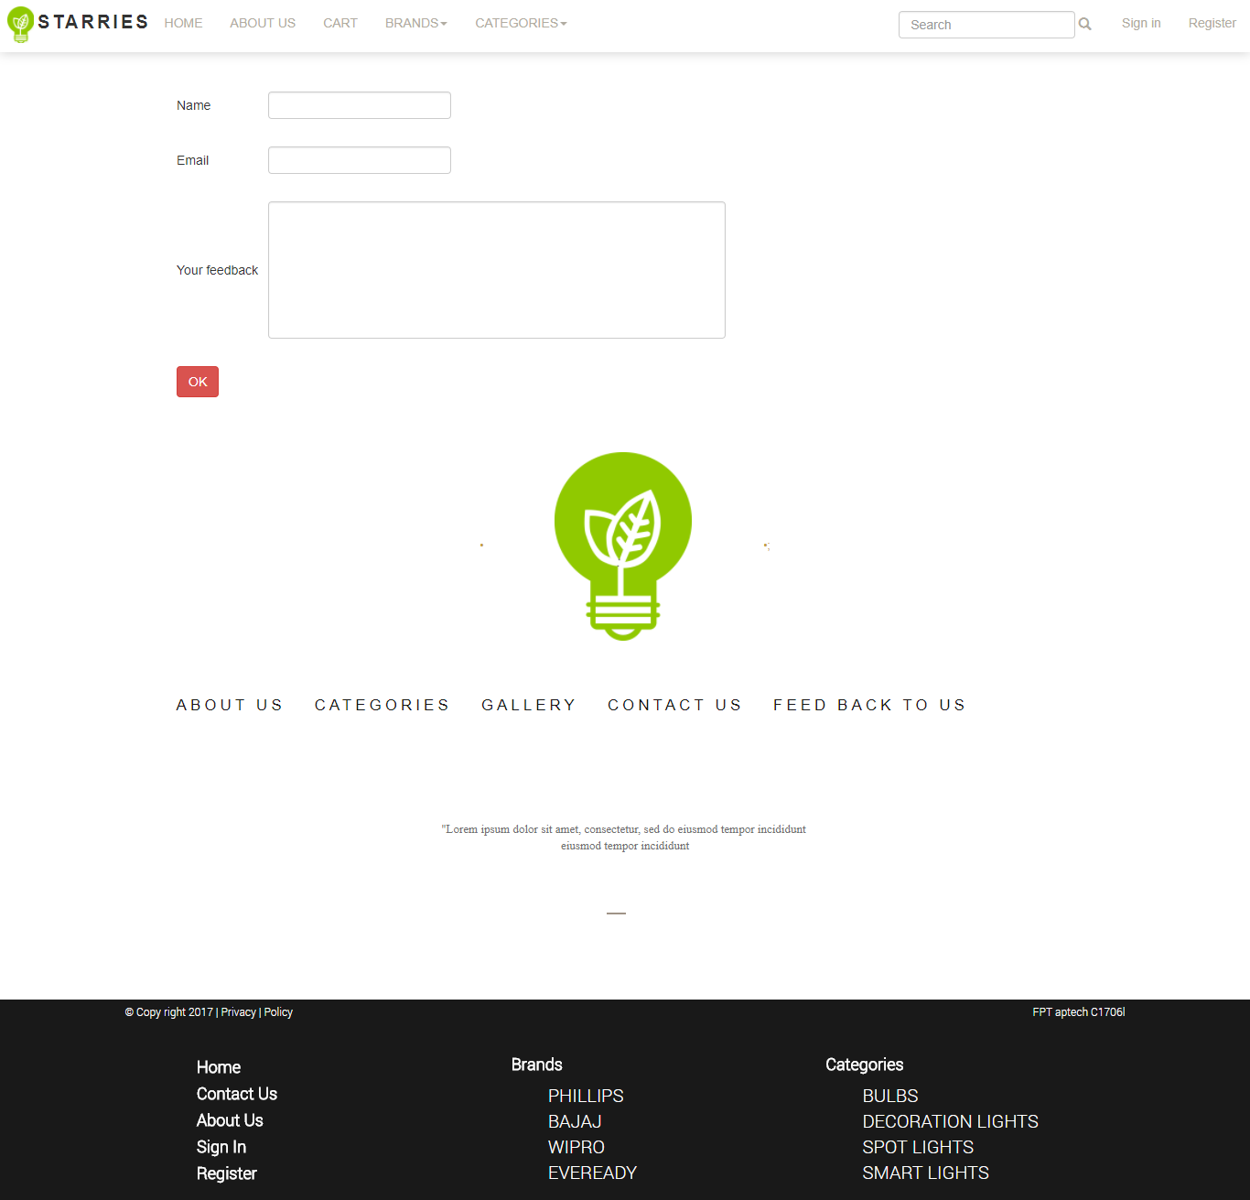

## Cart

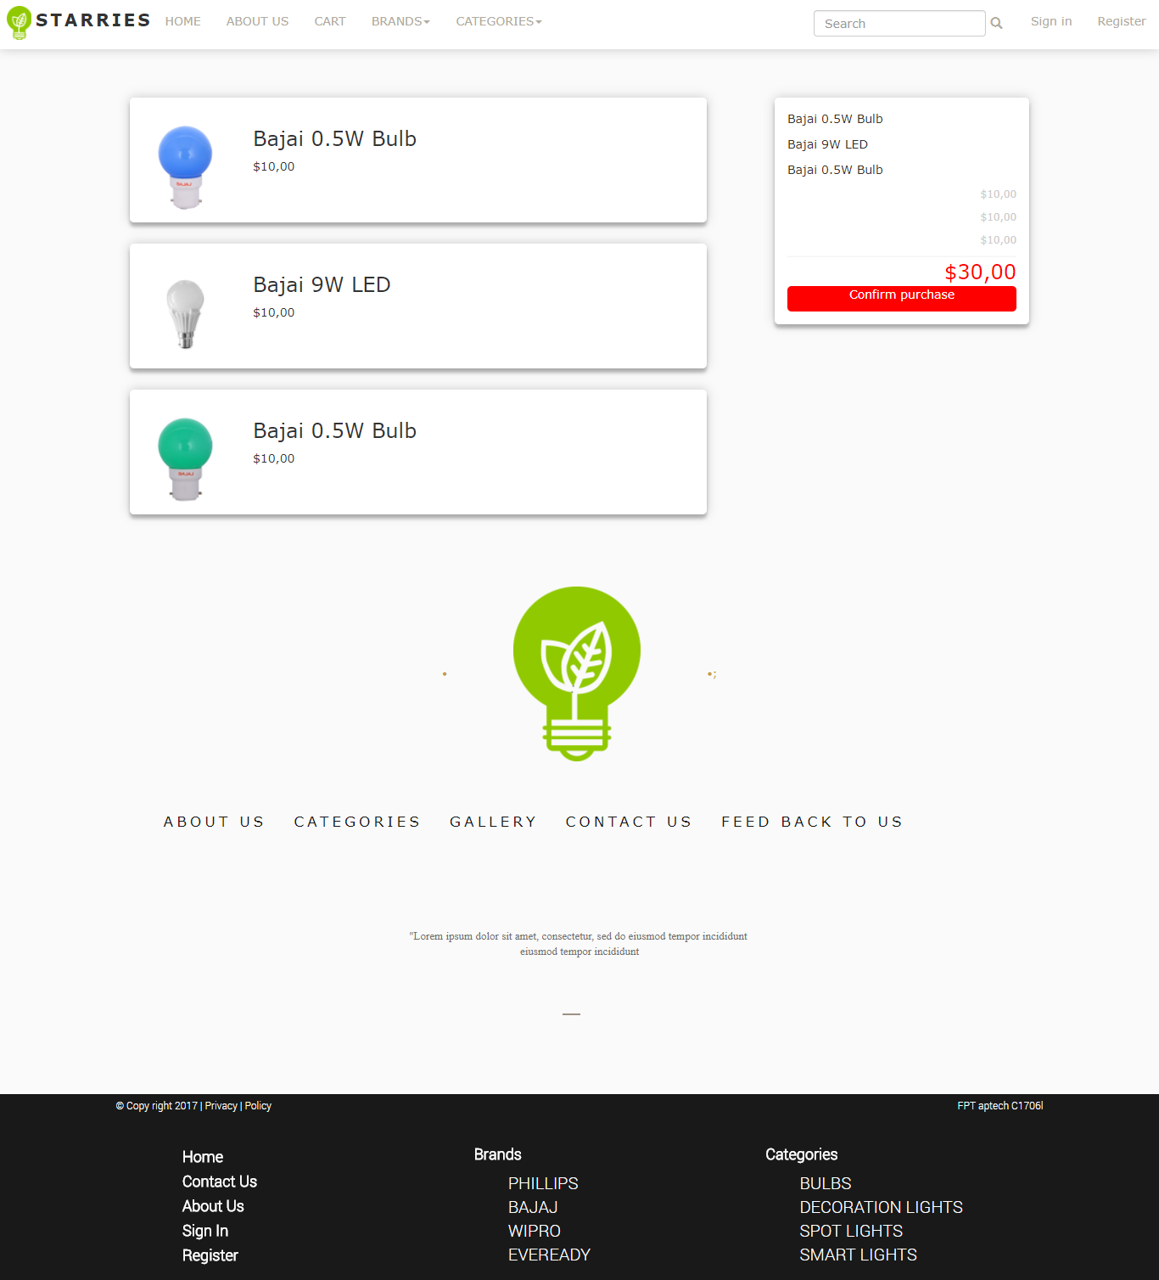

## Login

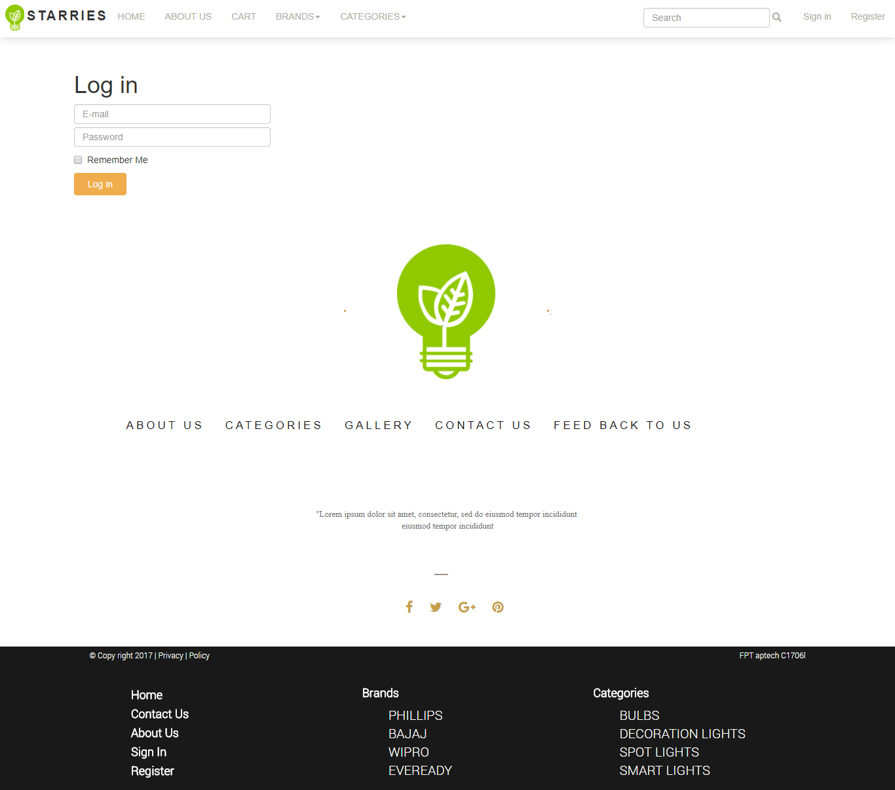

## Register

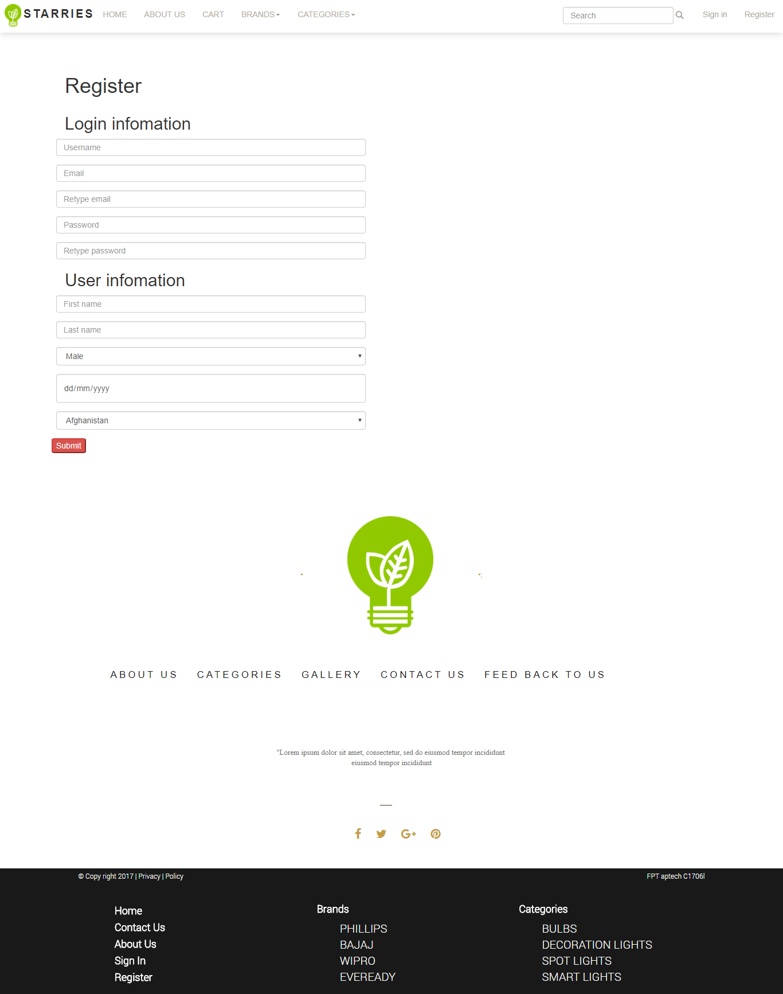

## All Brands

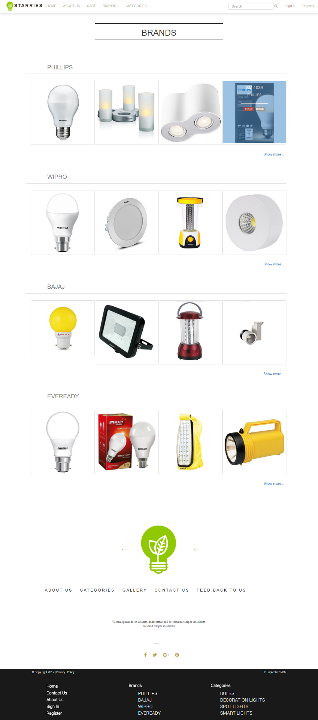

## Brands Details

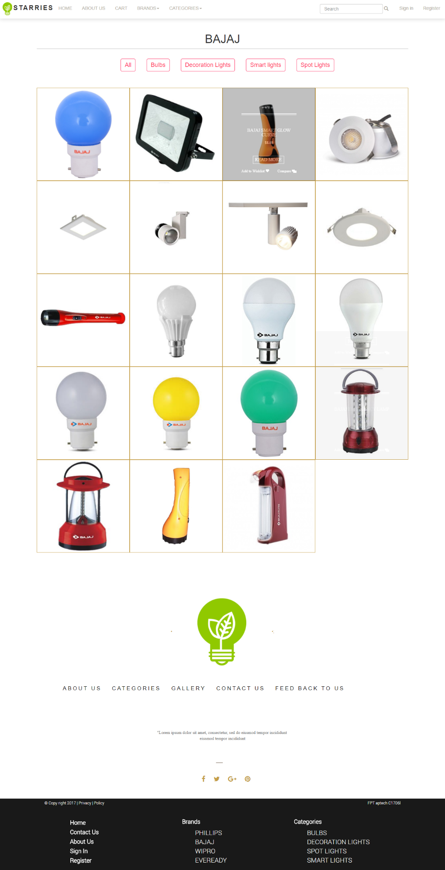

## All Categories

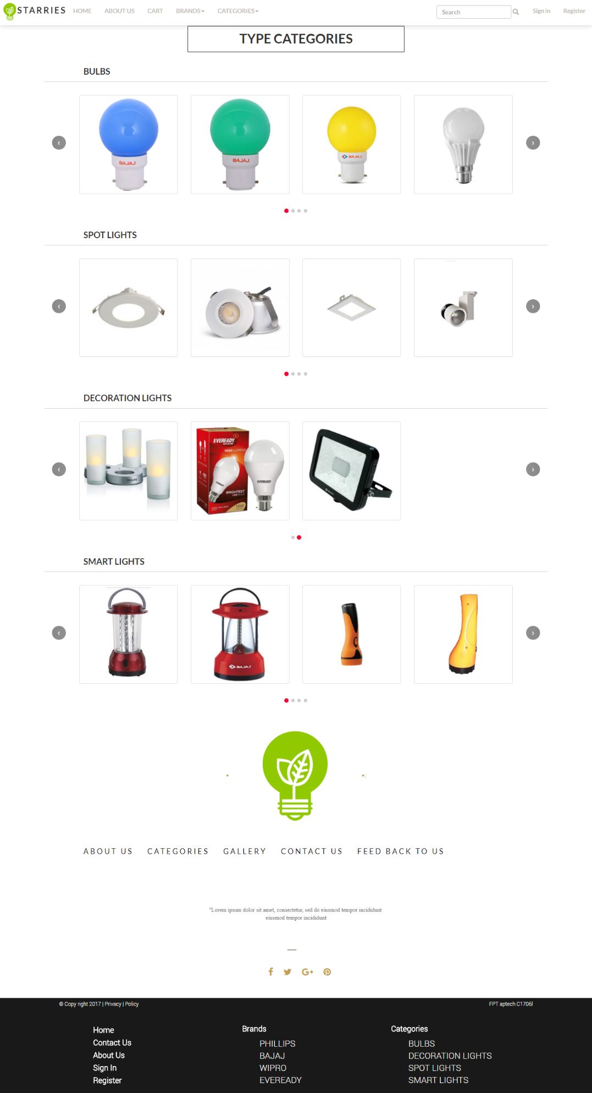

# Summary

The (x) means that person took part in the individual work

For instance : Nguyen Ngoc Thuy did the Homepage and Header ,...

|  |  |  |  |  |
| --- | --- | --- | --- | --- |
|  |  | Nguyen Ngoc Thuy | Nguyen Thu Thao | Nguyen Quoc Anh |
|  | Homepage | x |  |  |
|  | Header | x |  |  |
|  | Find resources: images and information of LEDs | x | x |  |
|  | Logo design |  | x |  |
|  | Login | x |  | x |
|  | Brands Details |  | x |  |
|  | All Brands |  | x |  |
|  | Categories |  | x |  |
|  | All Categories |  | x |  |
|  | Contact us |  | x |  |
|  | About us |  |  | x |
|  | Footer |  | x | x |
|  | Register |  |  | x |
|  | Search |  |  | x |
|  | Product Details |  | x |  |
|  | Merge Code | x | x |  |